FOR IMMEDIATE RELEASE

CONTACT INFORMATION:
All Bodies on Bikes
Marley Blonsky 206-601-7053
marley@allbodiesonbikes.com

ALL BODIES ON BIKES TEAMS UP WITH SBT GRVL TO CONTINUE PROMOTING SIZE-INCLUSION IN GRAVEL BIKE RACING
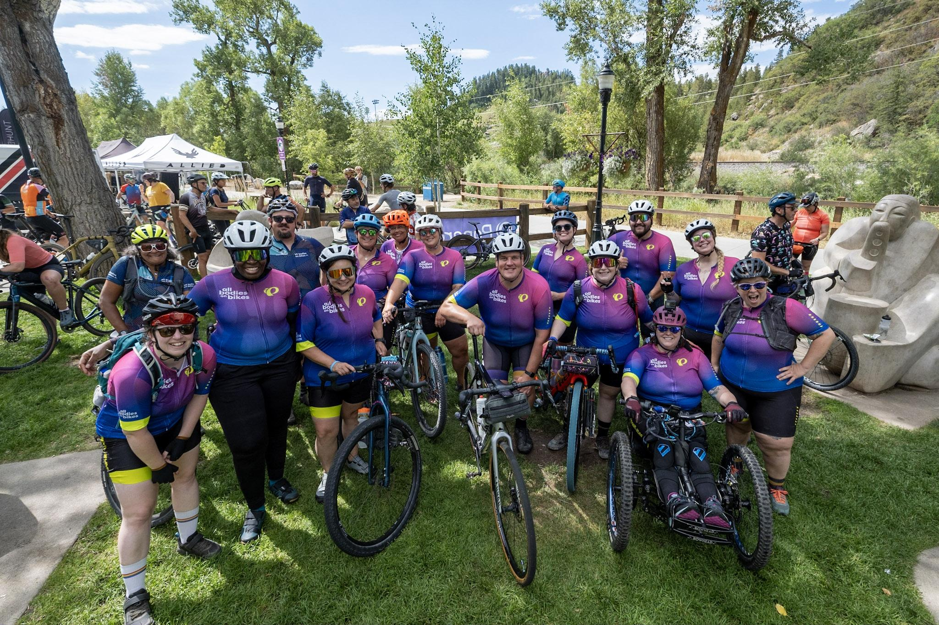

10 Spots will be reserved for a cohort of non-traditional athletes who will be supported in their preparation and training

Bentonville, AR, October 2023 — All Bodies on Bikes (ABOB) is a movement to create and foster a size-inclusive bike community founded by self-proclaimed “fat-cyclist” Marley Blonsky.

For the third year, All Bodies on Bikes has teamed up with Colorado’s SBT GRVL race to offer 10 non-traditional athletes a supported SBT GRVL weekend adventure. We are looking for athletes who may be new to gravel racing and looking for a supportive space to take on a new challenge.

Applications for the program open on Sunday, October 15th and close on Tuesday, October 31st at midnight. Selected participants for the 2024 cohort will receive a free registration for SBT GRVL 2024 for the distance of their choice (37, 60, 100, or 142 miles).

The program also includes mentorship by a cohort of other All Bodies on Bikes athletes and alumni, including co-founders Marley Blonsky and Kailey Kornhauser. Leading up to SBT GRVL, athletes will participate in monthly training calls with professional cycling coaches, gravel biking champions, endurance event veterans and the team behind SBT GRVL to support their success.

“This was an incredible experience, and one of the greatest bike events I’ve done. I’m forever grateful to be a part of All Bodies on Bikes and to help make cycling a more inclusive space.” - 2023 All Bodies on Bikes SBT GRVL Team Member

About All Bodies on Bikes: All Bodies on Bikes is a registered non-profit, founded in 2020 as a social and educational movement to create and foster size-inclusive bike communities. All Bodies on Bikes envisions a world where anyone, regardless of body size, weight, or perceived fitness level can safely enjoy a bike ride in a way that is joyful to them.

All Bodies on Bikes is currently seeking sponsorships to help defray the costs associated with travel, equipment, and housing for our 2024 team participating at SBT GRVL. Please contact Marley Blonsky for sponsorship or donation inquiries.

More information on the program, eligibility guidelines, FAQs and applications are available at https://www.allbodiesonbikes.com/about-the-program-24
###

